**HOMEWORK**

**NAME: Alice Miranda**

**CLASS: 3 “B” Contabilidad**

**DATE: 01/05/15**

1. She must take her medicine every day.



1. Lucy must go to her grandma’s house today.



1. Peter must not drink alcohol during 5 days.



1. Mary must do her homework if she doesn't want to get a 0.

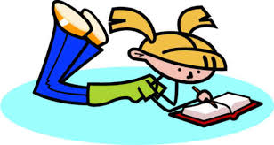

1. Josh must cook a cake for tonight.



1. You must stop at the curb and look before you cross the street.

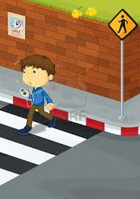

1. Children must listen to the teacher if they want to learn.

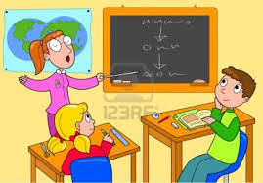

1. If you want to be healthy, you must eat a lot of fruits and vegetables.

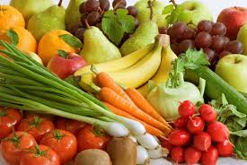

1. . Drivers mustn’t park their cars in the middle of the road.



1. You must always tell the truth.

