HOMEWORK
NAME: Miriam Guacho
DATE: 11 DE Mayo
CLASS: 3 Contabilidad “B”
TOPIC: Use too or enough pag 54
WRITE 40 CENTENCES TOO AND IS NOT ENOUGH.
1.-This sweater is too short . It doesn't fit me. 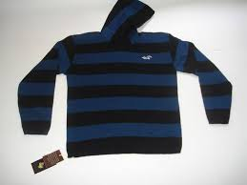
2.-These shoes are too tight. It can't wear them. 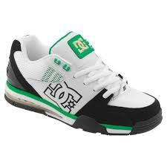
3.-This jacket isn't warm enough . I need a different one. 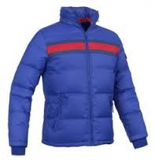
4.-This skirt is too short. It doesn't fit me. 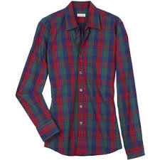
5.-This pants is too long. It can´t wear them. 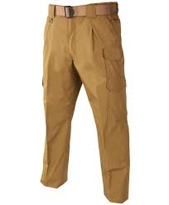
6.-These boots isn´t warm enough. I need a hot. 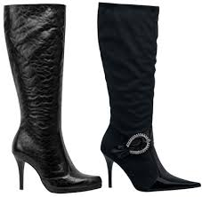
7.-This socks are too loose. I need a small. 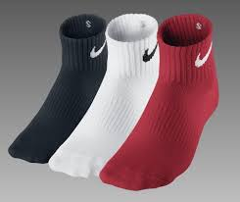
8.-These jeans are too short for me. 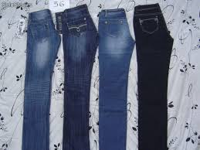
9.-My brother is too inteligent . He need prepare much.
10.-You are walking too quickly. Please slow down. 
11.-I can´t reach the ball because I'm not tall enough.
12.-Social studies is too very extensive. I need study. 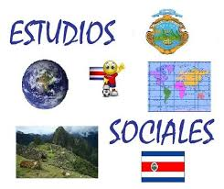
13.-This shirt isn´t long. I need a small. 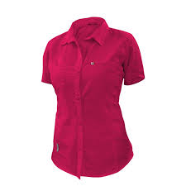
14.-You are too young to see this movie. I need another movie interesting. 
15.-I'm sorry . Your project isn´t good enough. I need one more concreto. 
16.-Let´s not go to the beach today. It's too cold. I need a coat. 
17.-My shoes aren´t big enough. 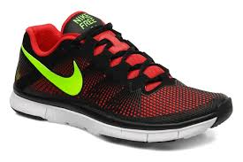
18.-Ouch! These pants are too tight!. I need a long. 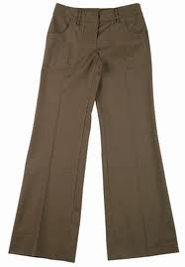
19.-Her hat isn´t big enough. You need a big. 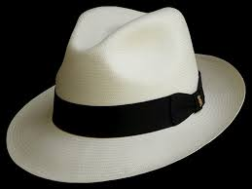
20.-He's too hot He need cold.
21.-His room aren´t quiet enough. 
22.-That sweater is too expensive. 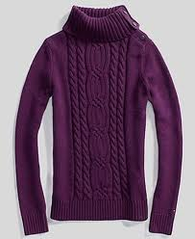
23.-The soup is too hot. I prefer little cold. 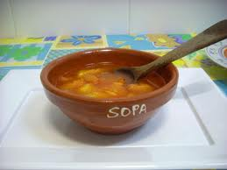
24.-There tights is too long. I need a small. 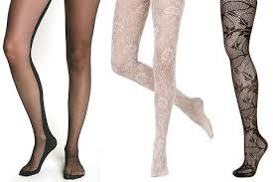
25.-My backpack is enough small. I need a big. 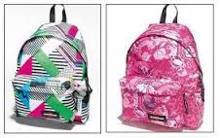
26.-This savannas is enough big for my mattress. 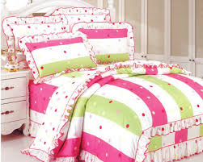
27.-This hair is too small. I want to more have big. 
28.-This table is enough long. It's necessary for do my homework. 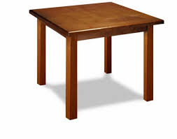
29.-This blackboard is enough small. I need a big. 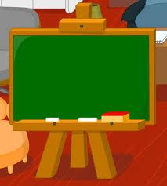
30.-This chair is enough small. It's necessary a big. 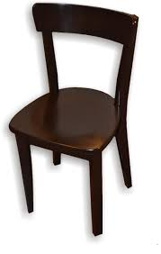
31.-English is enough wide to learn talk. 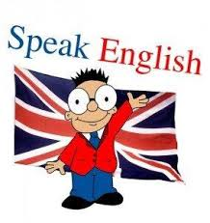
32.-Drawing is enough extensive theory technical. I need more practice. 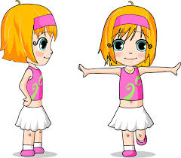
33.-My mother is too friendly to everyone its neighbors in the neighborhood. 
34.-You is enough understandable with his wife. 
35.-You aren't enough tall for play basketball. 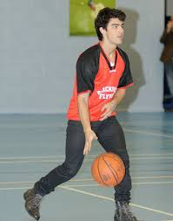
36.-Monica aren´t enough for the conference. I need a more people. 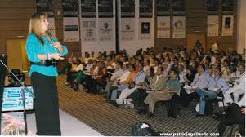
37.-Karina is enough good to play volleyball. 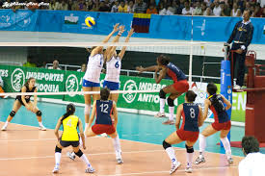
38.-Esther is enough intelligent for solve math exercises. 
39.-Juanes is too famous with your music worldwide. 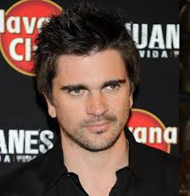
40.-This hair is too cancellous long. I need a hair cutting. 
41.-Camila is enough creative with their drawings. 

